A Project Report
on

COMPARITIVE ANALYSIS OF SPAM DETETION MODELS
carried out as part of the Deep Learning Lab project
Submitted

by

Ramya Mishra Ishar Singh
229309090 229309084

Data Science and Engineering

Under the Guidance of
Dr. Neha Sharma



ABSTRACT

In today's digital environment, where social media and online platforms are key communication tools, spam detection is increasingly important to protect the user experience and platform integrity. Spam, which often contains both image and text elements, requires sophisticated techniques to accurately identify and filter unwanted content. This research presents a comparative analysis of spam detection models using different deep learning techniques with a specific focus on incorporating Analytical Natural Language Processing (ANLP) like Word2Ve & One-hot-Encoding. The study examines the effectiveness of several models, including logistic regression, convolutional neural networks (CNNs), support vector machines (SVMs), and random forest classifiers, for detecting spam messages on two major platforms: emails and Facebook.
By applying ANLP methods, the research aims to improve the understanding and processing of majorly textual data & spam-images, which is key to improving the accuracy of spam detection. The performance of each model is evaluated in various metrics such as Confusion Matrix, Accuracy, Precision, Recall and F1-score to determine the most effective technique for each platform. In addition to evaluating individual models, the study compares how these techniques work across platforms, acknowledging that the nature of spam can vary significantly between email systems and social media environments. This comparative analysis provides valuable insights into the strengths and limitations of each approach and highlights which models work best for detection
- Introduction
1.1 Overview, Motivation, Applications and Benefits
In today's digital era, online platforms are essential for personal, professional and social interactions. While these platforms offer several advantages, they also face significant challenges, one of the most significant of which is the issue of spam. Spam messages, which usually include promotional content, phishing attempts or malicious links, flood communication channels and social media, leading to user frustration, data security risks and potential financial damage. Traditional spam detection methods primarily focus on text filtering, but as spam techniques evolve to include multimedia elements such as images with embedded text, detecting and filtering these complex messages is becoming more challenging. The primary motivation of this project is to improve the efficiency and accuracy of spam detection systems using image-text correlation techniques. These techniques seek to capture both the textual and image characteristics of spam messages, providing a more comprehensive approach to identifying and filtering spam across online platforms such as email, Facebook and other social media sites. Improved spam detection systems offer significant applications in digital marketing, cybersecurity, social media management, and user experience design.
A key benefit of this research is its potential to reduce the impact of spam on users, increase data security, and create a safer online environment by accurately identifying spam in both image-rich and text-rich formats.

1.2 Problem Statement
Detecting spam on online platforms is becoming increasingly difficult as spam messages now often contain multimedia content such as images with embedded text or mixed media messages. Traditional text spam filters are unable to effectively detect these hybrid spam messages. This project seeks to address this limitation by performing a comparative analysis of image-text correlation techniques using convolutional neural networks (CNNs) and other advanced models to increase the robustness and accuracy of spam detection on platforms such as email and Facebook.

  - Objectives
The objectives of this project are as follows:
- Perform a comparative analysis of Convolutional Neural Networks (CNN) and other
state-of-the-art spam detection models.
2. Evaluate the performance of these models using image-text correlation techniques.
3. Identify the strengths and weaknesses of each model in handling different types of spam.
4. Provide an overview of optimizing spam detection on various online platforms.

1.4 Project Scope
This project focuses on investigating and evaluating various machine learning techniques, especially CNN and other advanced models, for spam detection using image-text correlation. The project includes text and image preprocessing, feature extraction, model training, and performance analysis to achieve robust cross-platform spam filtering. By implementing and testing these models on datasets from email services and social media platforms, the study aims to identify the most effective approaches for real-world applications.

2.Background detail

  - Conceptual overview / literature review

Spam detection has seen significant progress, from simple keyword-based filtering to more sophisticated machine learning and deep learning techniques. Early spam detection systems have primarily relied on natural language processing (NLP) methods such as n-grams, bag of words, and TF-IDF (Term Frequency-Inverse Document Frequency) to identify suspicious words or phrases. These text-based techniques, while effective for detecting traditional spam messages, have become inadequate as spam messages increasingly contain multimedia elements such as images containing embedded text.
To address these limitations, modern spam detection systems have evolved towards hybrid models capable of detecting both text and image spam. Recent advances in deep learning, particularly Convolutional Neural Networks (CNNs), have gained traction due to their ability to extract complex features from images, making them highly effective for image-based spam detection. In conjunction with CNN, the use of Analytical Natural Language Processing (ANLP) techniques such as Word2Vec and One-Hot Encoding for text data further improved the detection process.
These techniques allow the model to better understand and process the textual components of spam messages, making it easier to detect spam with subtle linguistic variations. Spam detection is now a multimodal task that combines CNN for image processing with NLP-based embedding such as Word2Vec, GloVe or One-Hot Encoding for text data. This hybrid approach improves the model's ability to identify complex spam messages by correlating visual and textual features. CNN architectures such as ResNet-50, VGG, and Inception have demonstrated excellent feature extraction capabilities in image recognition tasks, allowing them to identify spam characteristics embedded in images when trained on spam-specific data.
Word embedding like Word2Vec provides a richer semantic understanding of the text and improves the detection of spam messages that may contain different language expressions. Studies have shown that models containing both image and text data significantly outperform traditional text-only filters, especially on platforms such as social media, where images are often an integral part of spam messages. These multimodal models offer a more comprehensive approach to spam detection and address the challenges posed by the increasing use of images and multimedia in spam messages.
However, challenges remain, including the computational cost associated with training such models and the difficulty of recognizing contextual nuances between text and images. Despite these challenges, the potential of hybrid models to increase the accuracy and robustness of spam detection is considerable. This research aims to evaluate and compare different deep learning models, including CNN and other state-of-the-art techniques, for spam detection on different platforms. By focusing on a combination of image and text correlation methods, the study will determine which models are most effective for detecting spam in a variety of datasets, including those from email systems and social media platforms such as Facebook.

  - Other software engineering methodologies

In the development of an image-text spam detection correlation system, an agile methodology is a suitable approach due to its iterative nature that allows flexibility in model refinement and testing. Agile emphasizes incremental progress and continuous feedback, which is essential when experimenting with different machine learning models and configurations. This approach allows for adjustments based on intermediate results, ensuring that each iteration leads to improvements in accuracy and performance. Another relevant methodology is the Cross-Industry Standard Process for Data Mining (CRISP-DM), which is often used in data science projects. CRISP-DM provides a structured framework that includes phases such as business understanding, data understanding, data preparation, modeling, evaluation, and deployment. Using this framework, the project systematically approaches spam detection by first understanding the cross-platform nature of spam data, preparing and pre-processing the data for model input, building different models for benchmarking, and evaluating their performance. This approach ensures that project goals are aligned with practical outcomes, making it easier to adapt the best-performing model to a real-world application environment. Finally, for efficient collaboration and version control, this project also uses DevOps practices, especially through tools like Git for code management and Jenkins or Google Colab for model deployment and testing. The combination of these methodologies ensures that the project follows a structured, adaptable and collaborative approach to achieving robust spam detection results.
3.System Design & Methodology

3.1 System architecture
The system architecture of this spam detection project consists of several key components for efficient processing and classification of image and text data. The high-level structure includes data preprocessing, feature extraction, and classification. Below is an overview of the architectural flow:
1. Data preprocessing: The system first preprocesses the input data, which includes both text and images. Text data is cleaned, tokenized and embedded using Word2Vec, while image data is transformed and normalized for CNN input. This preprocessing ensures that both text and images are in a compatible format for feature extraction.
2. Feature extraction:
- Text Feature Extraction: Cleaned and tokenized text data is converted to Word2Vec embedding to capture semantic relationships in the text.
- Image Feature Extraction: Images are passed through a pre-trained ResNet-50 model that extracts image features suitable for distinguishing spam characteristics.
3. Multimodal fusion: Text and image elements are combined using concatenation or an attention-based mechanism to create a unified message representation. This combination of image and text features allows the model to capture correlations between visual and textual elements in spam messages.
4. Classification: The merged features are passed to a classification layer (eg fully connected layer or softmax function) to produce a binary classification: spam or not spam.
5. Output and evaluation: The output of the model is classification results, which are then evaluated using metrics such as accuracy, precision, recall, and F1-score to assess its spam detection performance. The procedural approach of our research paper is represented in figure 1. 1, showing the sequential process from data preprocessing to output evaluation.
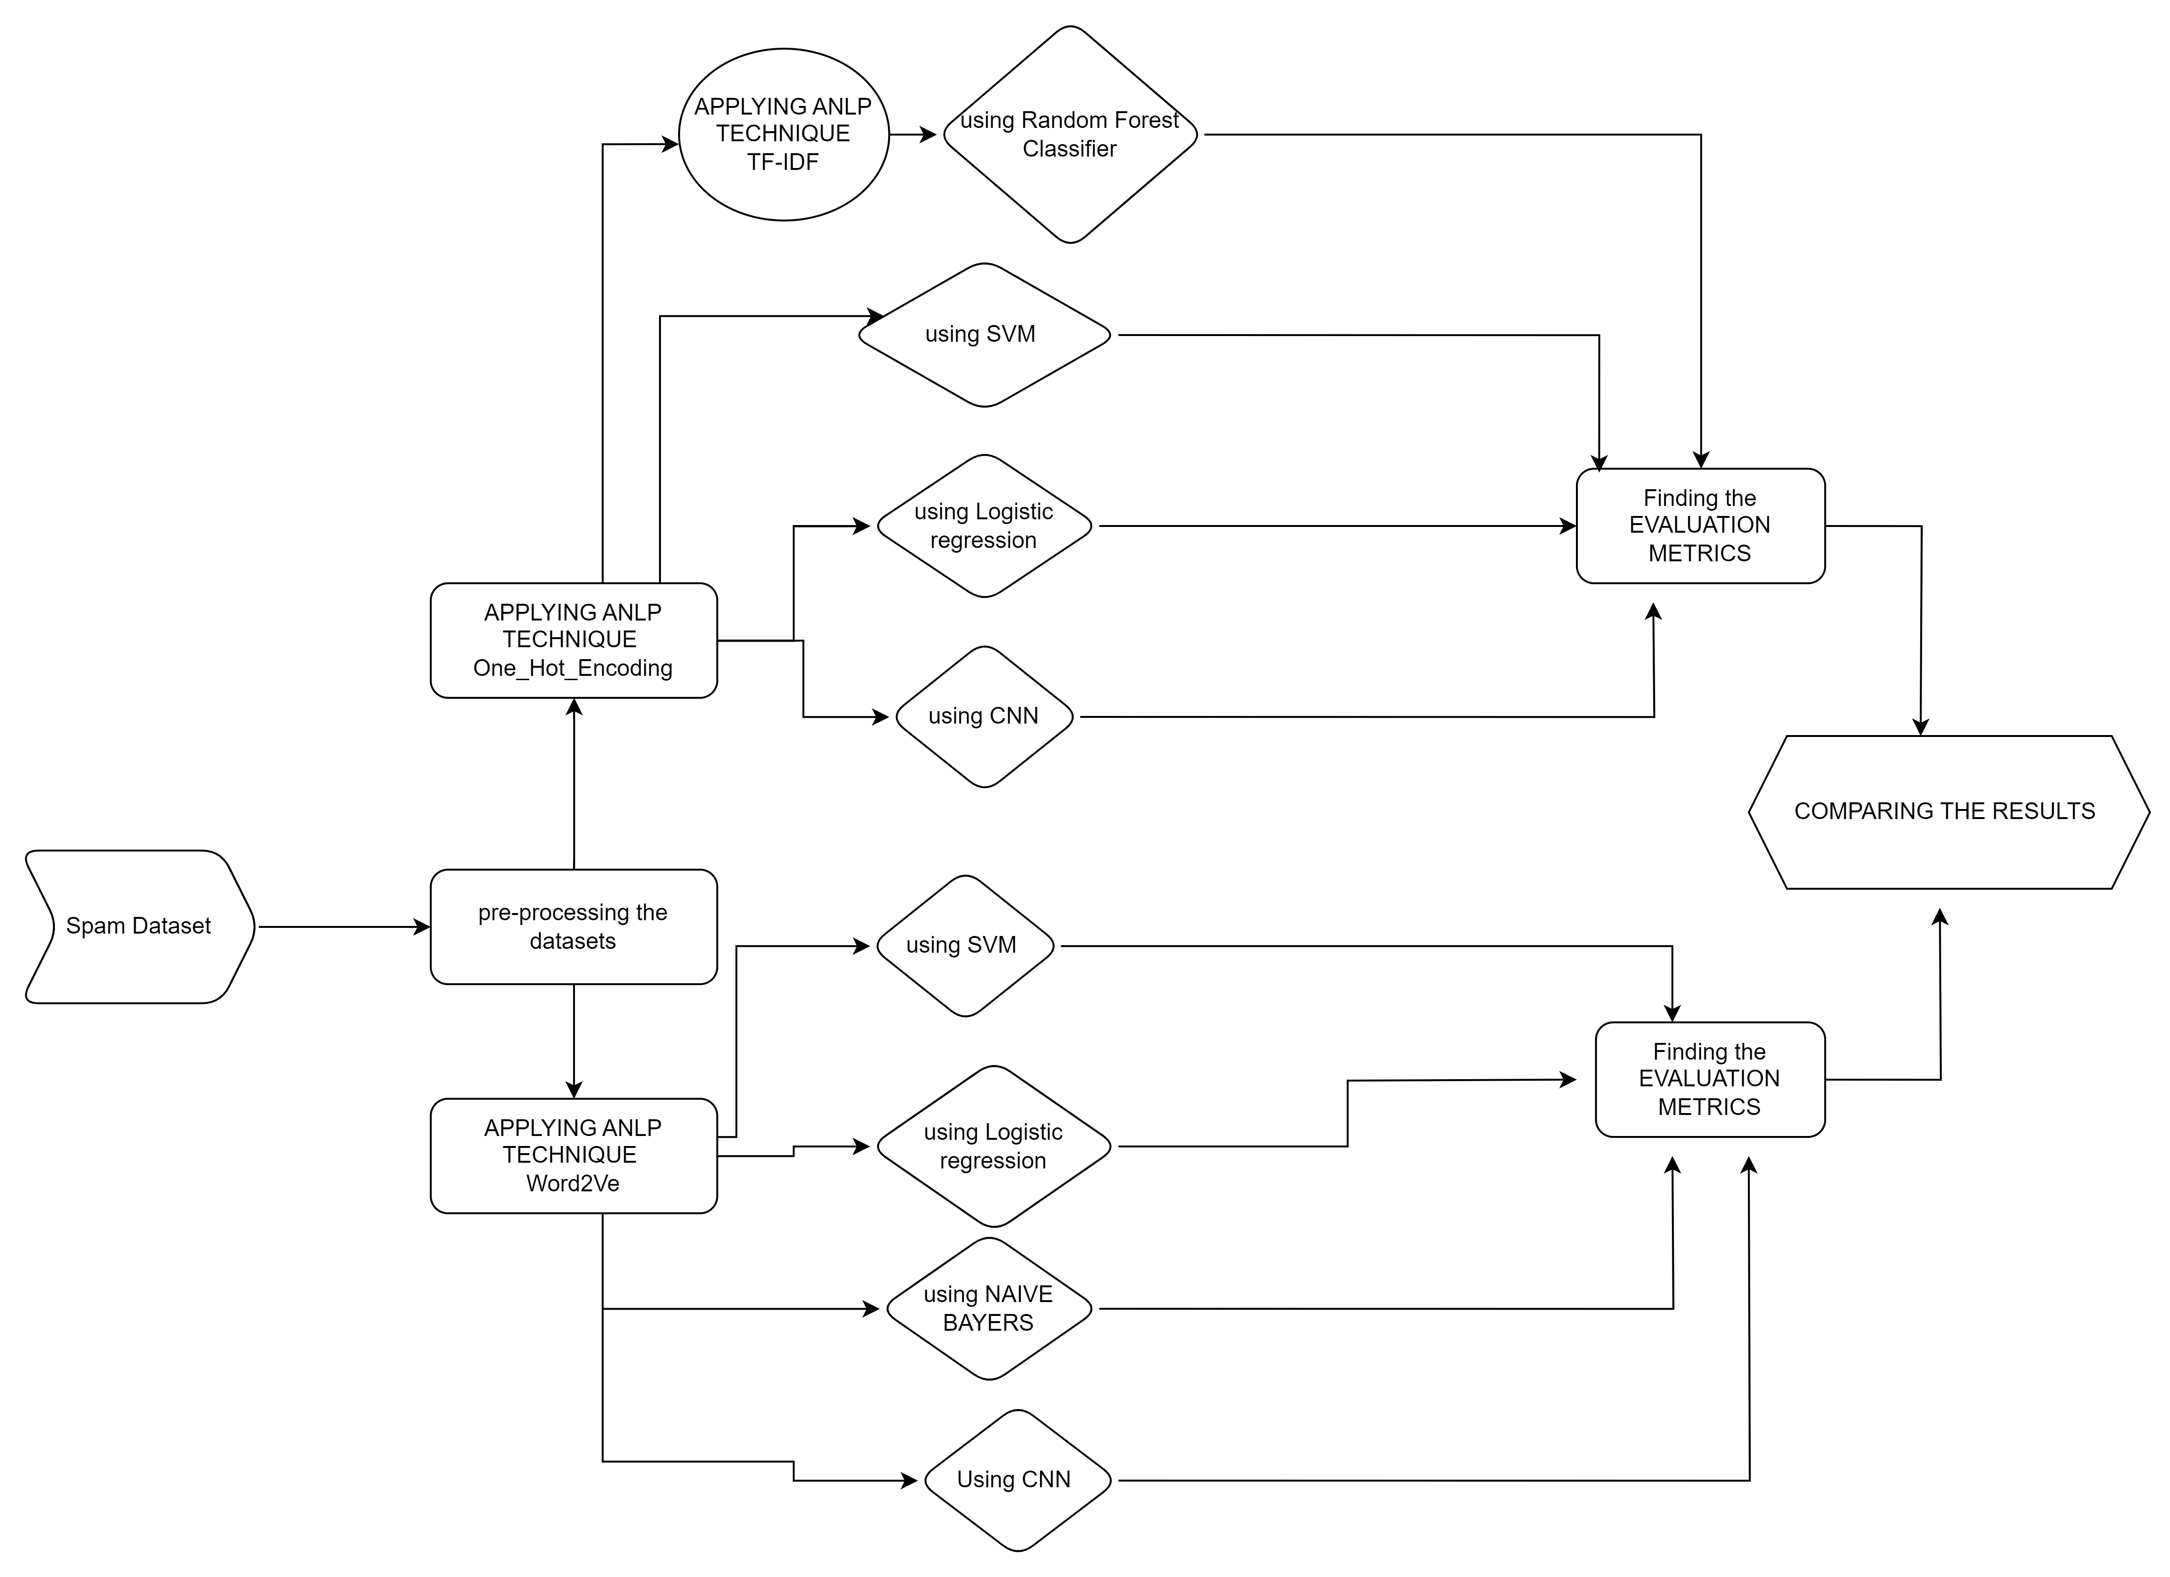

Figure 2.1-flow of work
3.2 Development Environment (Hardware & Software)
Hardware Requirements:
- Processor: Intel Core i5 or above (or equivalent) for local development
- RAM: Minimum 8GB (16GB recommended for handling large datasets)
Software Requirements:
- Programming Language: Python 3.9 or above
- Libraries: TensorFlow or PyTorch for model development, Keras for neural network building, NLTK for text preprocessing, and Gensim for Word2Vec embeddings
- Development Tools: Google Colab for cloud-based training, Jupyter Notebook for local development, and Git for version control
- Operating System: Windows, macOS, or Linux
- Other Tools: OpenCV for image processing, Matplotlib/Seaborn for data visualization, and Scikit-Learn for evaluation metrics

3.3 Methodology
- Throughout the process we used 4 datasets, two data sets dealing with spam email texts & images and two dealing with Facebook spam text & posts. Here we combine two ANLP techniques & combine them with Multiple Deep Learning models.
- Data Preprocessing:
  - Text Data Preprocessing:
    - Clean the text data by removing unnecessary characters, punctuation, and stopwords.
    - Tokenize the text and generate Word2Vec embeddings to create vector representations of each word, capturing semantic meaning.
  - Image Data Preprocessing:
    - Resize images to a fixed size compatible with the ResNet-50 model (e.g., 224x224 pixels).
    - Normalize the pixel values for consistency and compatibility with the pre-trained model.

- Email text using Word 2Ve- To run the experiment, we first deploy the necessary libraries to support our machine learning operations. Then load the configuration file and split it into training and testing.
- A Word2Vec model is then created to capture the word representation. We define a function to calculate the average Word2Vec vector for each sentence and set the size of the vector according to the set of Word2Vec models. Using this function, we transform each sentence in training and testing into an average Word2Vec vector.
- After preparing the data, we start training three classifiers: Random Forest, Logistic Regression and Support Vector Machine (SVM). Make test setup predictions using accuracy and F1 test scores and evaluate model performance. In addition, a confusion matrix is ​​calculated and plotted to provide more information about model prediction and misclassification.

- FB Text using Word 2Ve –
- The first step in our approach is to provide the necessary libraries to support machine learning. We then load the dataset and split it into training and test sets to ensure good evaluation.
- Create a Word2Vec model to learn word embeddings and create a function to calculate the average Word2Vec vector for each sentence. The dimensions of the vector are set according to the properties of the Word2Vec model. Using this function, we transform the sentences in the training and test text into average Word2Vec vectors.
- We then trained three classifiers (Gaussian Naive Bayes, Logistic Regression and Support Vector Machine (SVM)) on the training data. Make predictions on test settings and evaluate model performance by calculating accuracy and F1 scores.
- To further analyze the results, we calculated and visualized the confusion matrix to gain a deeper understanding of the process performance. Posts on FB using Word 2VE First, we installed and deployed the necessary data processing and machine learning libraries.
- Download core resources (such as the "punkt_tab" resource) from the NLTK library to support document tokenization. Then load the dataset and do an initial test by displaying the first few rows. This is followed by cleaning up the data, removing the NaN values, and ensuring that the array contains data. If necessary, tag text to word using simple segmentation or multiple tokenization methods.
- The identified sentences (represented as lists of individual words) are then fed into the Word2Vec model for training. After completing the training, the Word2Vec model can be saved or used directly. A function is defined to calculate the average Word2Vec vector for each book and convert all data into Word2Vec feature vectors. Prepare a data log and divide the data into training and test.
- Several classifiers received training data, such as logistic regression, support vector machine (SVM), convolutional neural network (CNN), and Gaussian Naive Bayes. Make predictions on the test set and evaluate model performance using accuracy and F1 test scores. Finally, a confusion matrix is ​​calculated and plotted to display the results and further evaluate the effectiveness of the method.
- Email text using One Hot Encoding First-
- import the libraries needed for data management and machine learning. The data is imported, and a preliminary test is performed by displaying the first few rows. The data then goes through a cleaning process that involves removing overlapping lines and selecting individual lines for single-bit encoding.
- The selected rows are assigned a one-time encoding, and the newly updated rows are merged with the remaining data. Review the updated configuration files to identify changes and save the final configuration file as a new CSV file for further analysis. Then the data is split into training and testing, with 80% allocated to training and 20% to testing.
- Various learning machines are trained on the training data, including logistic regression, random forest, support vector machine (SVM), and convolutional neural network (CNN). Make predictions on the test set and evaluate model performance by calculating accuracy and F1 scores. Finally, a confusion matrix is ​​calculated and visualized to further evaluate the predictive ability of the model.
- Email images using One Hot Encoding –
- The process begins by uploading a ZIP archive containing the image dataset to Google Colab and then extracting the images by extracting the archive. To ensure that only relevant files are processed, files are filtered to specifically select image files in .jpg or .png formats. Then use the Pillow library to load and display images for content consumption.
- Once you have prepared the data, load the DenseNet121 model for further analysis. The model is then evaluated on the measured values ​​and makes predictions for each image. Analyze model performance by calculating accuracy and F1 scores and calculate and visualize confusion matrices to provide detailed information on model performance.

- FB Text using One Hot Encoding –
- The process begins by supplying the necessary data management and machine learning libraries. Data is imported and stored in a Pandas DataFrame for easy processing and analysis. The data set is then cleaned by categorically selecting each one and then converted to a numerical representation using one-time coding.
- These cultures are combined with other data to prepare for modeling. The data set is then split into training and test sets, with 80% of the data set for training and 20% for testing. A set of classifiers, including logistic regression, support vector machines (SVMs), random forests, and convolutional neural networks (CNNs), are trained on the data.
- Make predictions on the test set and evaluate model performance by calculating accuracy and F1 scores. Finally, the confusion matrix is ​​calculated and plotted to obtain more information about the model's prediction performance and error distribution.
- FB post using One Hot Encoding
- The process begins by supplying the necessary data management and machine learning libraries. Data is imported and stored in a Pandas DataFrame for easy processing and analysis. The data set is then cleaned by categorically selecting each one. Submit an image using a CNN model. The data set is then split into training and test sets, with 80% of the data set for training and 20% for testing.Make predictions on the test set and evaluate model performance by calculating accuracy and F1 scores. Finally, the confusion matrix is ​​calculated and plotted to obtain more information about the model's prediction performance and error distribution.

4. Implementation and Result

4.1 Modules/Classes of Project
The project is divided into several modules, each with specific classes that handle different aspects of the spam detection system:
- Data Loader Module:
- Data Preprocessor Class: This class handles data cleaning, tokenization, and formatting for text data, and resizing and normalization for image data.
  - Dataset Loader Class: Manages the loading of datasets and splitting them into training, validation, and test sets.
- Feature Extraction Module:
  - Text Feature Extractor Class: Implements Word2Vec embeddings to generate vector representations of text data.
  - Image Feature Extractor Class: Uses a pre-trained ResNet-50 model to extract features from images, capturing key visual patterns associated with spam.
- Fusion Module:
  - Fusion Layer Class: Combines the extracted text and image features into a single feature vector through concatenation or attention mechanisms. This class is central to integrating multimodal data for effective spam detection.
- Classification Module:
  - SpamClassifier Class: Implements a fully connected neural network that receives the fused features and classifies messages as spam or not spam.
  - Evaluator Class: Calculates performance metrics (accuracy, precision, recall, F1-score) to assess the model’s effectiveness.
- Visualization Module:
  - Visualization Tools Class: Plots training and evaluation results, such as loss curves, accuracy trends, and confusion matrices, to provide insights into model performance.

4.2 Implementation Detail
Implementation of this methodology would involve creating several machine learning pipelines to classify text and image data using Word2Vec embedding and one-time encoding for different data types. Here's a closely related breakdown of the methodology for Email Text, FB Text, FB Posts, Email Images, and FB Text with implementations for Word2Vec embedding and one-time encoding: Steps for text data using Word2Vec
    - Load libraries and data: Import libraries like Pandas for data processing, Sklearn for machine learning, Gensim for Word2Vec and NLTK for text processing. Load a dataset, check its structure, and split it into training and test sets.
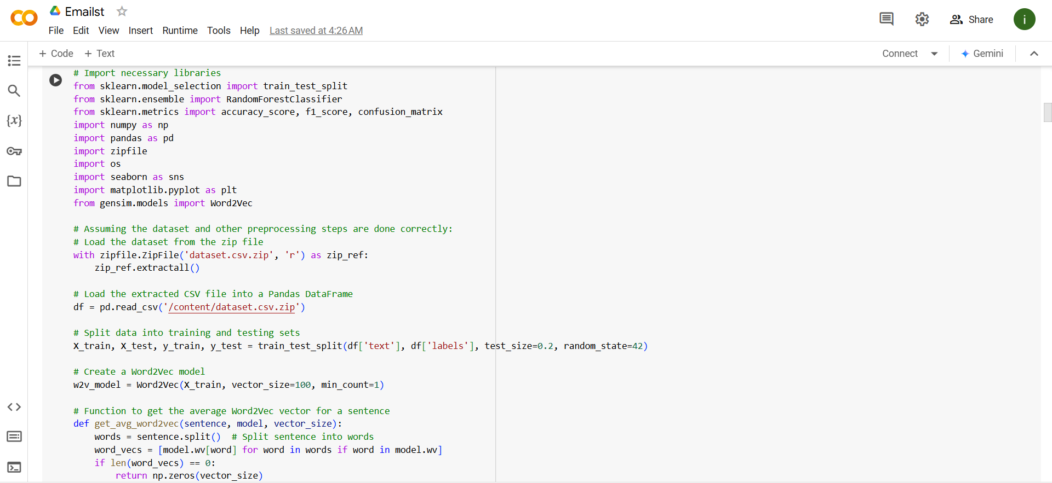
Figure-4.1 Loading libraries

    - Data cleaning: Pre-process the text by tokenizing and removing ignored words, punctuation and any other unwanted elements. Make sure the text fields are not null.
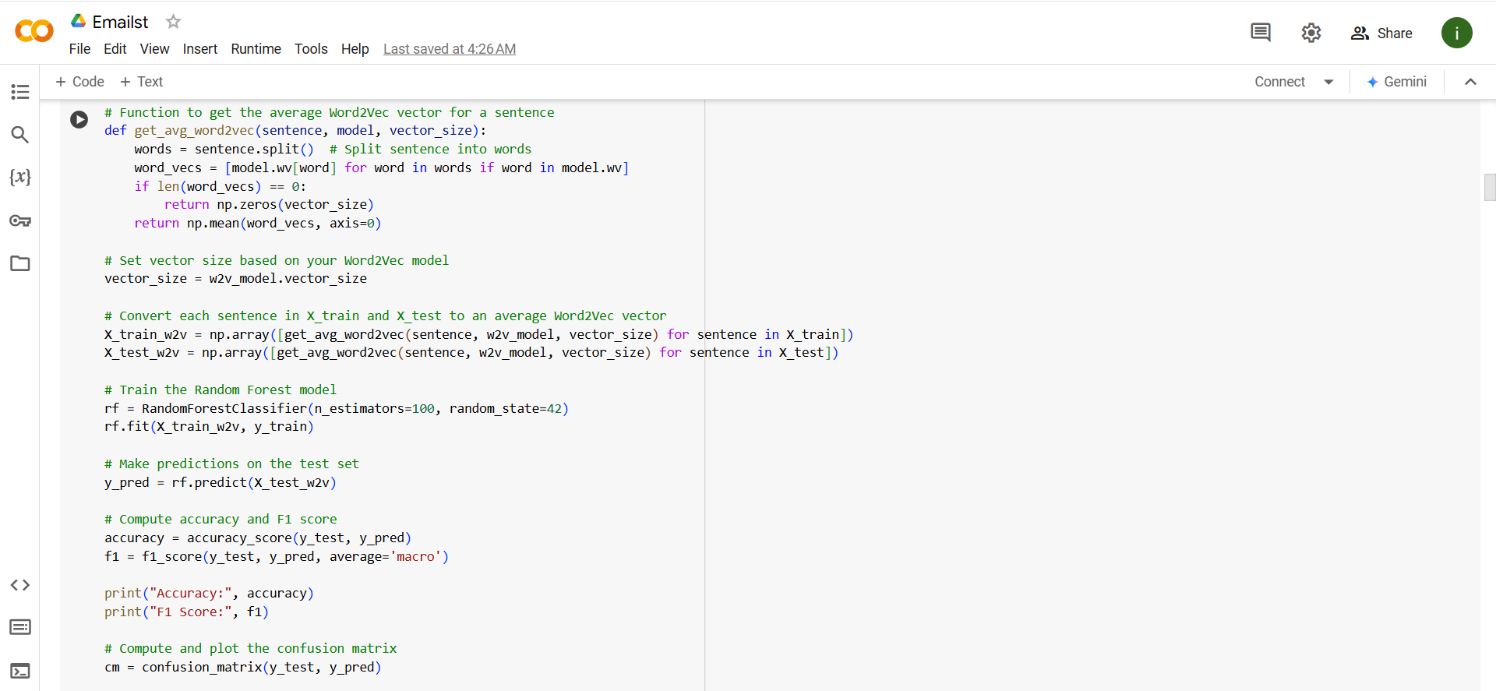
Figure-4.2 Data cleaning code

    - Insert Word2Vec:
Train a Word2Vec model or use a pre-trained Word2Vec model to generate embeddings for each word in the text.

- Define a function to calculate the average Word2Vec vector for each sentence and set the
- embedding dimensions according to the Word2Vec configuration.
- Convert the sentences in the training and test sets to average Word2Vec vectors.

    - Classifier training:
- Train classifiers (random forest, Naïve Bayes, logistic regression and SVM) using the averaged Word2Vec vectors as features.
5. Evaluation:
- Make predictions on the test set and evaluate using accuracy and F1 scores.
- Compute and plot the confusion matrix to visualize prediction performance and misclassification 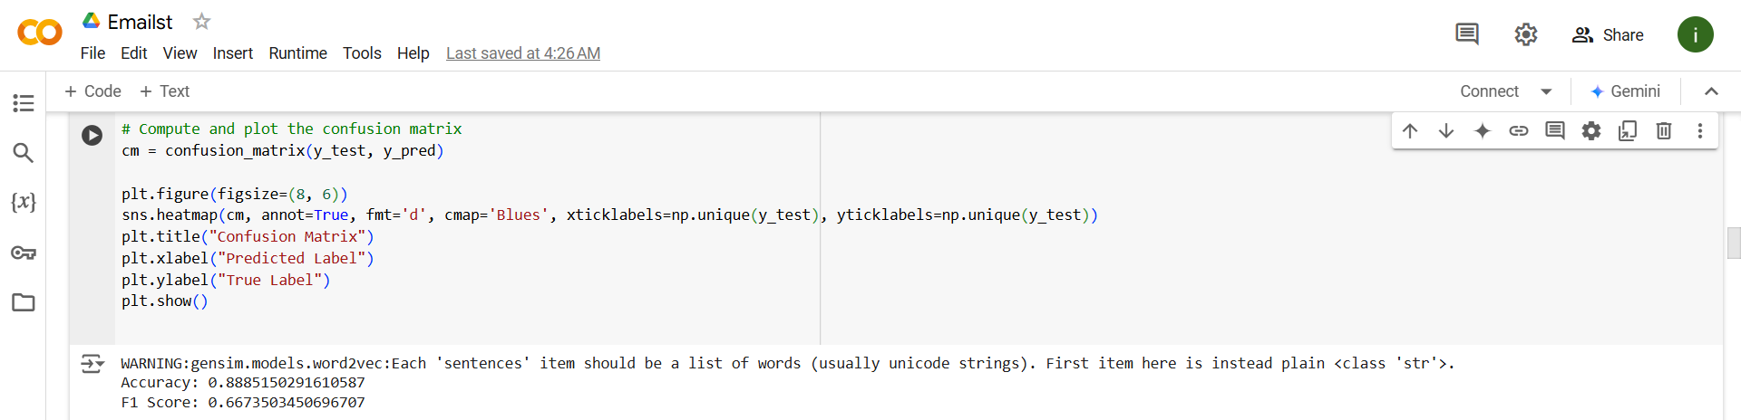
Figure-4.3 Evaluation metrics code

Steps for text data using One-Hot Encoding
      - Load libraries and data: Import required libraries and load data into DataFrame.
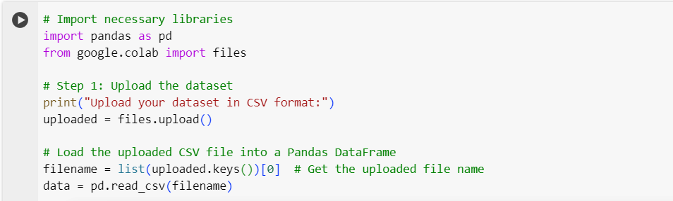
Figure 4.4 Load libraries and data for data using One-Hot Encoding code

2. Data cleaning and encoding:
- Select categorical columns for one-time coding and apply one-time coding to these functions.
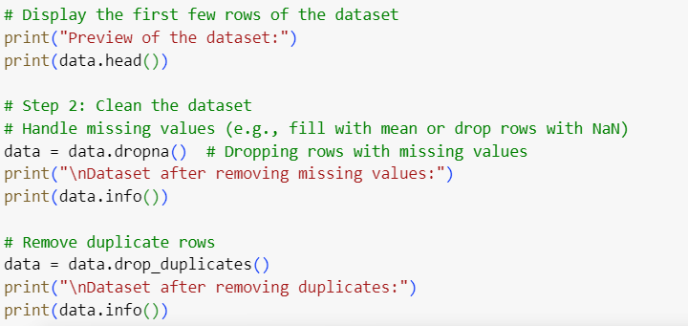
Figure -4.5 Data cleaning and encoding code

- Merge one-time encoded columns with the rest of the dataset.
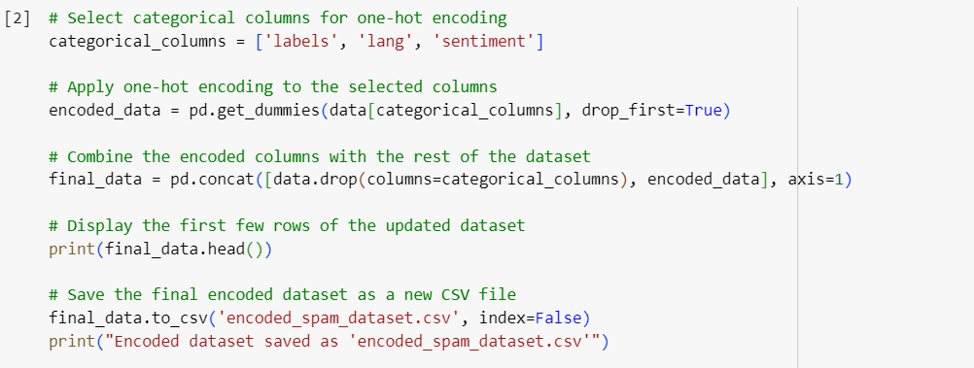
Figure -4.6 one-time encoded columns with the rest of the dataset Code

      - Split the data: Split the data into 80% for training and 20% for testing.
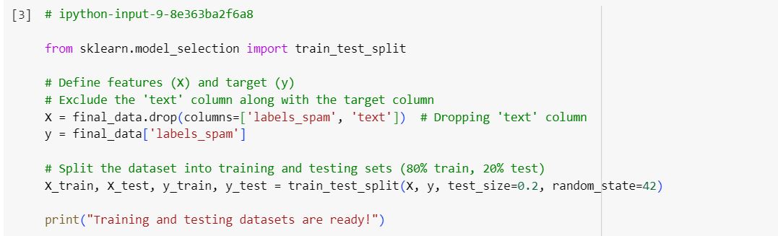
Figure-4.7 Split the data code

4. Classifier training:
- Train classifiers like Logistic Regression, Random Forest, SVM and CNN on the training set.

    - Evaluation:
- Make predictions on test data and evaluate them using accuracy and F1 scores.
- Compute and visualize the confusion matrix to assess prediction errors. Steps for Image Data Using One-Hot Encoding
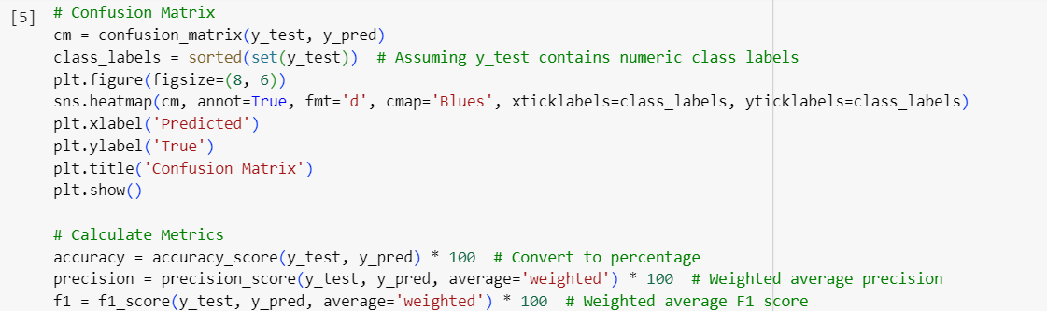
Figure -4.8 visualize the confusion matrix

FOR WORKING WITH IMAGES
      - Upload and extract files:
- In Google Colab, upload the image data ZIP file, extract it and filter the files to select .jpg or .png images.
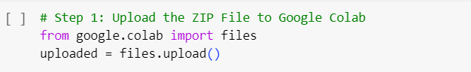
Figure-4.9 Upload and extract files

      - Loading the image:
- Use the Pillow library to load and display images and validate dataset contents.
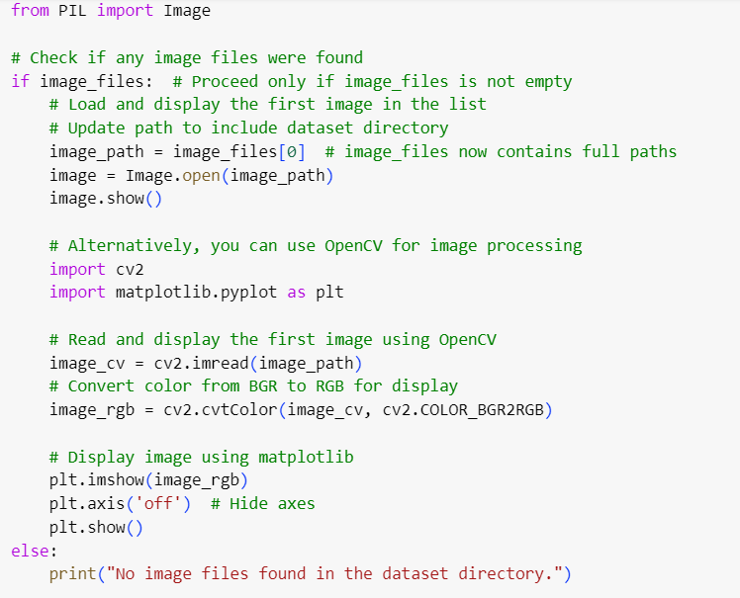
Figure-4.10 Loading the image code
      - Load and evaluate the model:
- Load the DenseNet121 model or other deep learning models.
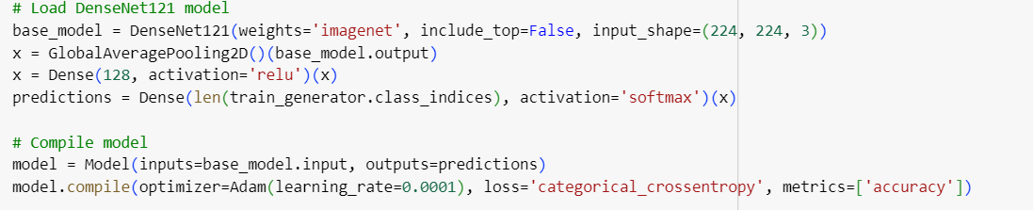
Figure- 4.11 Load the DenseNet121 code

- Use this model to make predictions on test images and evaluate accuracy and F1 scores
- Compute and plot the confusion matrix for additional performance information. 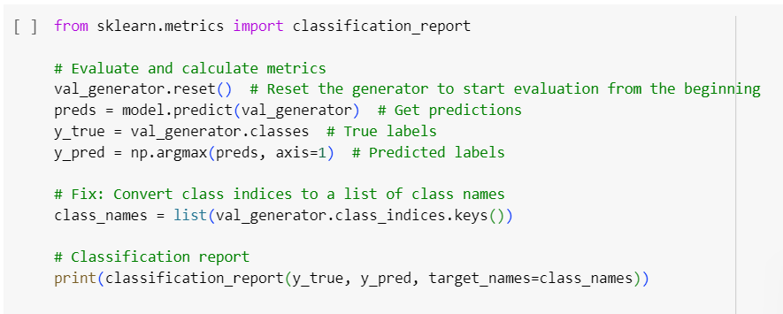
Figure-4.12 Compute and plot the confusion matrix code
4.3 Results and Discussion
Our assessment measures include accuracy ,precision,F1-score & confusion matrix. All these metrics are defined as follows:
- A confusion matrix is a performance evaluation tool for classification models. It provides a summary of prediction results by showing the counts of actual vs. predicted classifications across different classes. The matrix is particularly useful for binary or multiclass classification tasks.
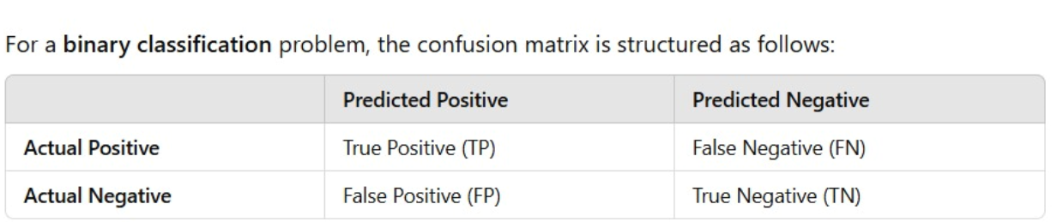
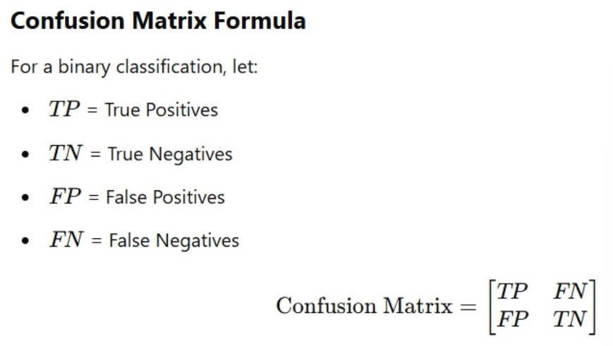
- Starting with the Observations we got from applying the ANLP technique One-Hot Encoding along with the machine & deep learning techniques.
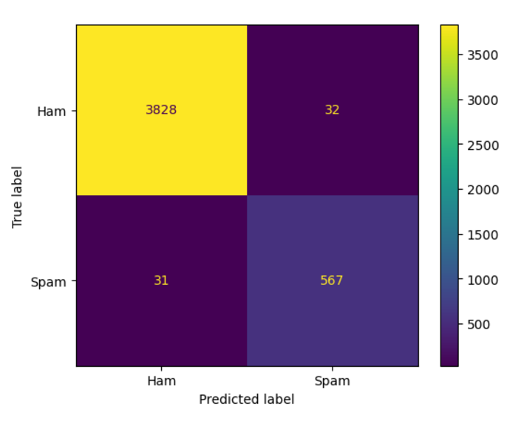
- CNN-
Confusion Matrix:
- Ham (0):
  - True Positives (Correctly classified as Ham): 3828
  - False Positives (Misclassified as Spam): 32
- Spam (1):
  - True Positives (Correctly classified as Spam): 567
  - False Negatives (Misclassified as Ham): 31

Figure 4.13 -confusion matrix for CNN email- image spam detection
model using One-Hot Encoding

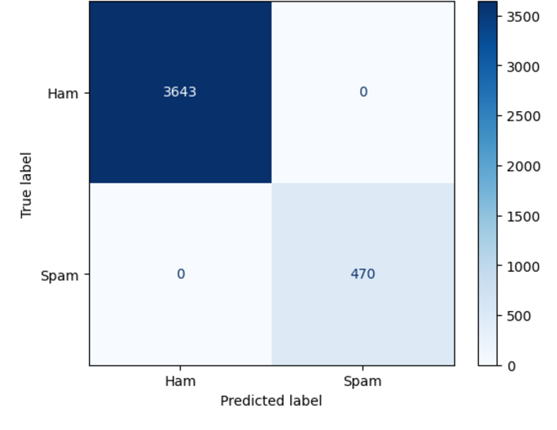
- RANDOM FOREST CLASSIFIER(USING ANLP TECHNIQUE TF-IDF)
Confusion Matrix:
Ham (0):
True Positives (Correctly classified as Ham): 3643
False Positives (Misclassified as Spam): 0
Spam (1):
True Positives (Correctly classified as Spam): 470
False Negatives (Misclassified as Ham):0

Figure 4.14 -confusion matrix for Random Forest Classifier email text
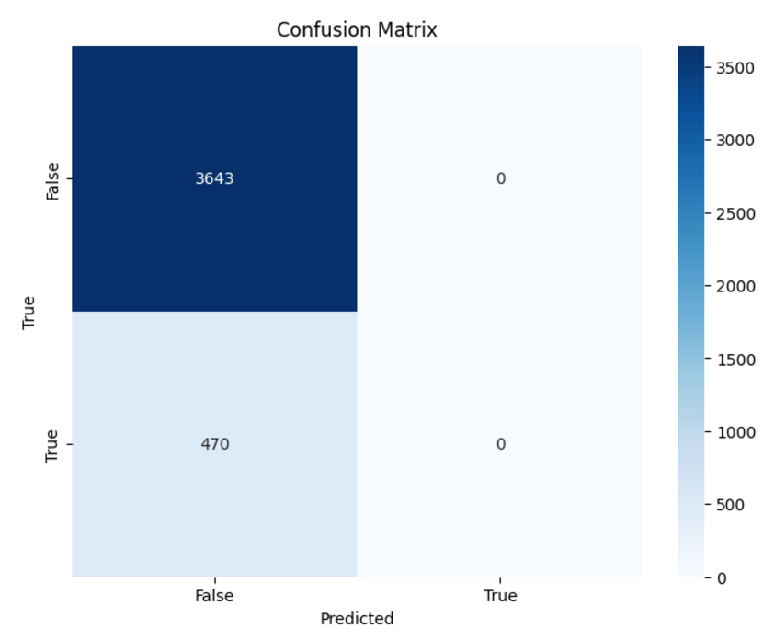
spam detection model using One-Hot Encoding

- SVM
Top-left (3643): True Negatives (TN) - The model correctly predicted "False" for 3643 instances.
Top-right (0): False Positives (FP) - The model incorrectly predicted "True" for 0 instances where the actual label was "False."
Bottom-left (470): False Negatives (FN) - The model incorrectly predicted "False" for 470 instances where the actual label was "True."
Bottom-right (0): True Positives (TP) - The model correctly predicted "True" for 0 instances False Negatives (Misclassified as Ham):0

Figure 4.15 -confusion matrix for SVM email spam detection model using One-Hot Encoding

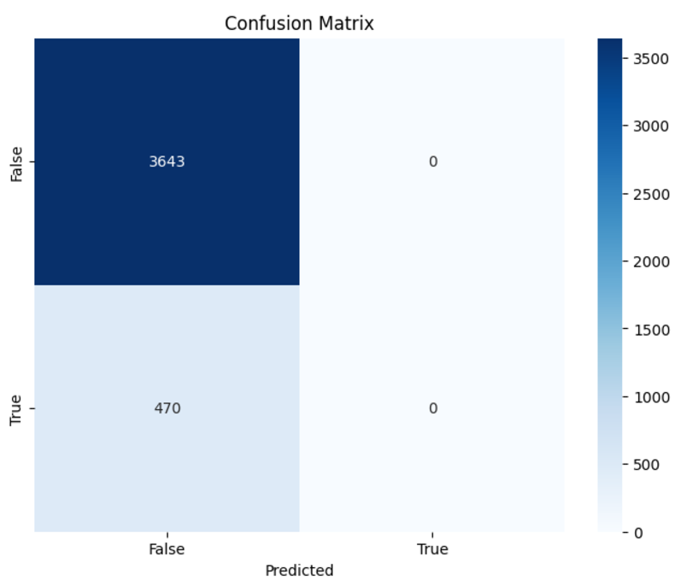
- LOGISTIC REGERSSION
Top-left (3643): True Negatives (TN) - The model correctly predicted "False" for 3643 instances.
Top-right (0): False Positives (FP) - The model incorrectly predicted "True" for 0 instances where the actual label was "False."
Bottom-left (470): False Negatives (FN) - The model incorrectly predicted "False" for 470 instances where the actual label was "True."
Bottom-right (0): True Positives (TP) - The model correctly predicted "True" for 0 instances False Negatives (Misclassified as Ham):0

Figure 4.15 -confusion matrix for Logistic Regression email spam
detection model using One-Hot Encoding

- Observations we got from applying the ANLP technique Word2Ve along with the machine & deep learning techniques.

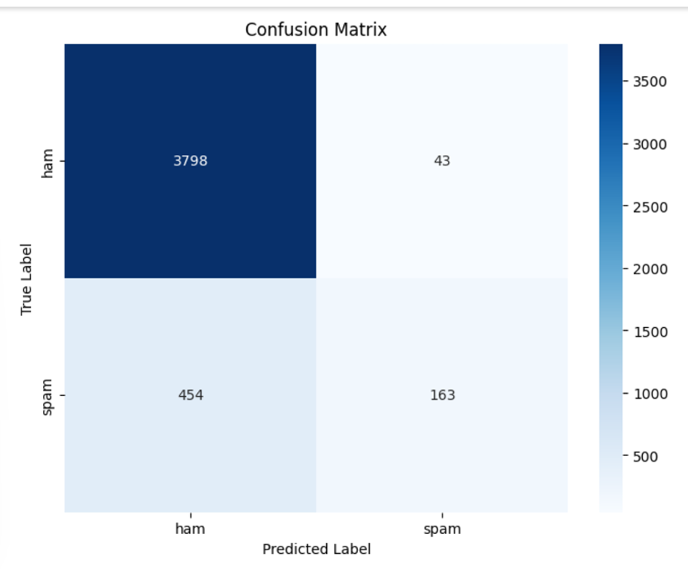
CNN, Random Forest, Naïve Bayes, Logistic Regression And SVM
Confusion Matrix:
- Ham (0):
  - True Positives (Correctly classified as Ham): 3798
  - False Positives (Misclassified as Spam): 43
- Spam (1):
  - True Positives (Correctly classified as Spam): 454
  - False Negatives (Misclassified as Ham):163
Figure 4.16-confusion matrix for all machine learning models
email spam detection model using One-Hot Encoding

- The rest of the assessment measures include accuracy ,precision & F1-score . These metrics are defined as follows:
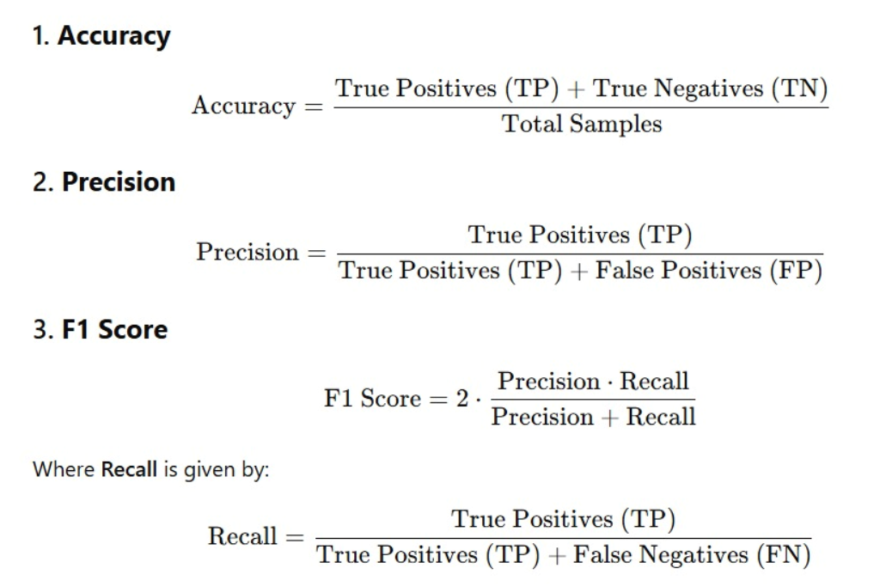

- Observations we got from applying the ANLP technique One-Hot Encoding along with the machine & deep learning techniques on the dataset – for email text spams (dataset.csv)
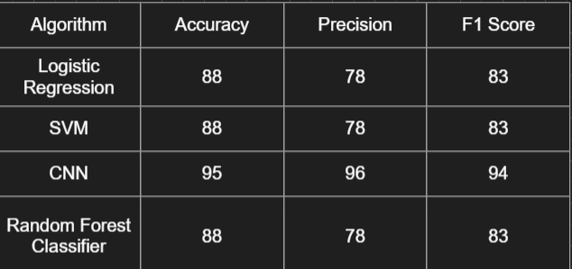
Figure 4.17- results for Accuracy, Precision & F1 Score email spam detection Using One-hot-encoding
- Accuracy: cnn demonstrates the highest accuracy (95%), followed by logistic regression, svm, and random forest (all 88%) This suggests that cnn is the most reliable in accurately classifying instances in general.
- Precision: cnn has the highest precision (96%), followed by logistic regression, svm, and random forest (all 78%) This implies that CNN is the most accurate in recognizing positive occurrences. CNN has the highest f1 score (94%), followed by logistic regression, support vector machine (SVM), and random forest (all 83%).
- This suggests that cnn is the most balanced algorithm in terms of precision and recall.
CNN seems to be the most promising algorithm based on its impressive accuracy, precision, and f1 score. It is the most accurate, precise, and balanced in terms of predicting positive outcomes. Logistic regression, support vector machine, and random forest exhibit comparable performances across various metrics.

- Observations we got from applying the ANLP technique One-Hot Encoding along with the machine & deep learning techniques on the dataset – for Facebook text spams (dataset.csv)

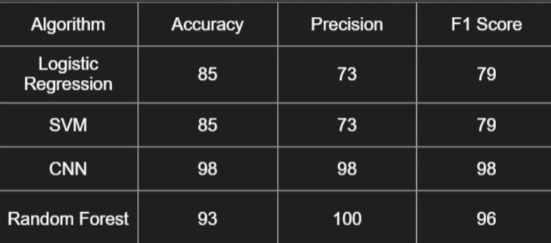
Figure 4.18- results for Accuracy, Precision & F1 Score FaceBook text spam detection Using One-hot-encoding
- Accuracy: CNN demonstrates the best Accuracy (98%), followed by way of Random Forest (ninety three%), and Logistic Regression and SVM (both 85%). This shows that CNN is the maximum correct in successfully classifying times normal.
- Precision: Random Forest has the best Precision (one hundred%), accompanied with the aid of CNN (98%), and Logistic Regression and SVM (each seventy three%). This indicates that Random wooded area is the most specific in identifying fine times.
- F1 score: CNN has the best F1 score (ninety eight%), accompanied with the aid of Random Forest (ninety six%), and Logistic Regression and SVM (each seventy nine%). This shows that CNN is the maximum balanced algorithm in terms of precision and don't forget.
CNN seems to be the maximum promising algorithm based totally on its high Accuracy, Precision, and F1 score. it is the most accurate, unique, and balanced in phrases of predicting tremendous times. Random forest additionally performs nicely, specially in terms of Precision. Logistic Regression and SVM, at the same time as having a decrease Accuracy and Precision, nonetheless have a respectable F1 rating.

- Observations we got from applying the ANLP technique Word2Ve along with the machine & deep learning techniques on the dataset – for email text spams (dataset.csv)
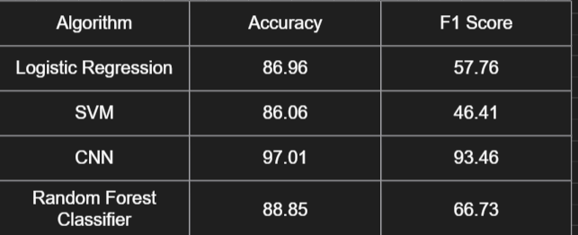
Figure 4.19-results for Accuracy & F1 Score for email text spam detection Using Word2Ve
The furnished table affords a evaluation of four gadget learning algorithms (Logistic Regression, SVM, CNN, and Random forest) based on their Accuracy and F1 score.
- Accuracy: CNN demonstrates the very best Accuracy (97.01%), followed by Random wooded area (88.85%), Logistic Regression (86.96%), and SVM (86.06%). This suggests that CNN is the maximum correct in correctly classifying instances common
- F1 score: CNN additionally has the highest F1 score (ninety three.forty six%), suggesting a great balance among precision and do not forget. Random wooded area (66.73%) has the second one-quality F1 rating, accompanied by means of Logistic Regression (57.seventy six%) and SVM (46.41%). This suggests that CNN and Random forest might be higher at predicting the high-quality elegance in comparison to the alternative algorithms.
CNN appears to be the maximum promising algorithm primarily based on each Accuracy and F1 rating. however, it is crucial to take into account the particular use case and the trade-off between Accuracy and F1 rating. If precision and don't forget are equally critical, CNN might be the nice desire. If Accuracy is the primary challenge, Logistic Regression or SVM is probably suitable options.

- Observations we got from applying the ANLP technique Word2Ve along with the machine & deep learning techniques on the dataset – for Facebook text spams (spam.csv)
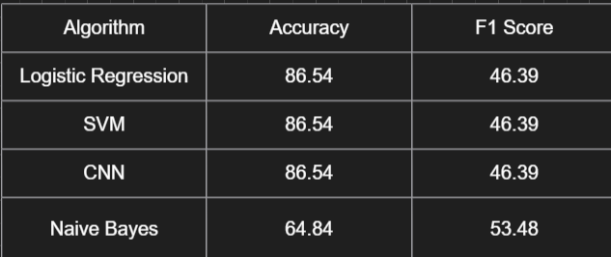
Figure 4.20-results for Accuracy & F1 Score for FaceBook text spam detection Using Word2Ve

In the assessment of 4 system studying algorithms (Logistic Regression, SVM, CNN, and Naive Bayes) primarily based on their Accuracy and F1 rating. even as all algorithms show a high Accuracy rating (86.54% for LR, SVM, and CNN, and 64.84% for Naive Bayes), their F1 scores are substantially lower. This indicates that these models may not be appropriately predicting the tremendous magnificence, main to a better number of false positives and false negatives.
- Accuracy: All algorithms, besides Naive Bayes, have a high Accuracy score, indicating their capacity to properly classify times overall.
- F1 rating: The low F1 scores for all algorithms suggest ability troubles with precision and bear in mind. this will be due to imbalanced datasets or the complexity of the problem domain.
- Naive Bayes: while having a lower Accuracy than the opposite algorithms, it reveals a barely higher F1 rating, indicating better overall performance in terms of precision and bear in mind as compared to the others.

- Observations we got from applying the ANLP technique Word2Ve along with the machine & deep learning techniques on the dataset – for Facebook posts spams (fbpost.csv)

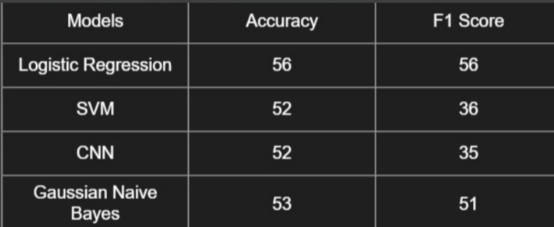
Figure 4.21-results for Accuracy & F1 Score for FaceBook text spam detection Using Word2Ve

The table compares 4 models (Logistic Regression, SVM, CNN, and Gaussian Naive Bayes) primarily based on Accuracy and F1 score, with the subsequent insights:
• Logistic Regression is the fine-appearing version, accomplishing the very best Accuracy (56%) and F1 rating (56%), making it the maximum balanced and reliable preference for this dataset.
• Gaussian Naive Bayes performs moderately well with an Accuracy of 53% and an F1 rating of 51%, imparting a balanced opportunity.
• both SVM and CNN exhibit comparable Accuracy (52%) but extensively lower F1 scores (36% and 35%, respectively), suggesting poor dealing with of class imbalance or function representation.

- Conclusion and Future Plan

By adopting this approach, we showcase a comprehensive framework for processing both textual and visual data through machine learning pipelines. By utilizing word2vec embeddings for text and one-hot encoding for both text and categorical data, the approach guarantees versatility and adaptability across various data types. When working with image data, utilizing pre-trained deep learning models such as densenet121 guarantees precise feature extraction and classification. This thorough approach enables accurate classification and evaluation across various datasets, employing metrics such as accuracy and f1 score to assess performance.

5.1 Future Plan
- Adjusting Our Models
- Conduct hyperparameter tuning for classifiers and word2vec configurations to enhance the performance of the model.
- Explore advanced deep learning models for text data, such as bert or gpt-based embeddings, to handle intricate language patterns.
- Improved data augmentation:
Utilize data augmentation techniques on image data to enhance model generalization and robustness.
- Scalability and deployment:
Package the pipelines into modular units for widespread adoption in large-scale projects.
Deploy the last models as APIs for real-time predictions in production environments.
- Assessment with practical information:
Evaluate the pipelines on actual datasets (e.g., live emails, social media posts) to verify their efficiency in dynamic situations.
- Integration and automation:
Streamline the preprocessing and classification tasks by utilizing integrated tools such as airflow or prefect, which enable continuous data processing and monitoring.

- References
[1] F. Ja´n˜ez-Martino, R. Alaiz-Rodrı´guez, V. Gonza´lez-Castro, E. Fidalgo, E. Alegre, A review of spam email detection: analysis of spammer strategies and the dataset shift problem, Springer, Artificial Intelligence Review, May 2022.
[2] A. Basit, M. Zafar, X. Liu, A.R. Javed, Z. Jalil, K. Kifayat, A comprehensive survey of AI-enabled phishing attacks detection techniques, Telecommun. Syst. 76 (1) (2021) 139–154.
[3] P.U. Anitha, C.G. Rao, D.S. Babu, Email spam filtering using machine learning based Xgboost classifier method, Turkish J. Comput. Math. Educat. 12 (11) (2021) 2182–2190.
[4] P. Pandey, C. Agrawal, T.N. Ansari, A hybrid algorithm for malicious spam detection in email through machine learning, Int. J. Appl. Eng. Res. 13 (24) (2018) 16971–16979.
[5] Y. Yang, S. Yoo, F. Lin, I.C. Moon, Personalized email prioritization based on content and social network analysis, IEEE Intell. Syst. 25 (04) (2010) 12–18.
[6] K.P. Thooyamani, V. Khanaa, R. Udayakumar, An integrated agent system for e-mail coordination using jade, Indian J. Sci. Technol. 6 (6) (2013) 4758–4761.
[7] G. Jain, M. Sharma, B. Agarwal, Spam detection in social media using convolutional and long short-term memory neural network, Ann. Math. Artif. Intell. 85 (1) (2019) 21–44.
[8] N. Spirin, J. Han, Survey on web spam detection: principles and algorithms, ACM SIGKDD explorations newsletter 13 (2) (2012) 50–64.

LIST OF FIGURES

Figure No | Figure Title
Figure 2.1 | Flow of work
Figure-4.1 | Loading libraries code
Figure-4.2 | Data cleaning code
Figure-4.3 | Evaluation metrics code
Figure-4.4 | Load libraries and data for data using One-Hot Encoding code
Figure-4.5 | Data cleaning and encoding code
Figure-4.6 | one-time encoded columns with the rest of the dataset Code
Figure-4.7 | Split the data code
Figure -4.8 | visualize the confusion matrix
Figure-4.9 | Upload and extract files
Figure-4.10 | Loading the image code
Figure- 4.11 | Load the DenseNet121 code
Figure-4.12 | Compute and plot the confusion matrix code
Figure 4.13 | confusion matrix for CNN email- image spam detection  model using One-Hot Encoding
Figure 4.14 | confusion matrix for Random Forest Classifier email text  spam detection model using One-Hot Encoding
Figure 4.15 | confusion matrix for Logistic Regression email spam
Figure 4.16 | confusion matrix for all machine learning models  email spam detection model using One-Hot Encoding
Figure 4.17 | results for Accuracy, Precision & F1 Score email spam detection Using One-hot-encoding
Figure 4.18- | results for Accuracy, Precision & F1 Score FaceBook text spam detection Using One-hot-encoding
Figure 4.19 | results for Accuracy & F1 Score for email text spam detection Using Word2Ve
Figure 4.20 | results for Accuracy & F1 Score for FaceBook text spam detection Using Word2Ve
Figure 4.21 | results for Accuracy & F1 Score for FaceBook text spam detection Using Word2Ve

.

